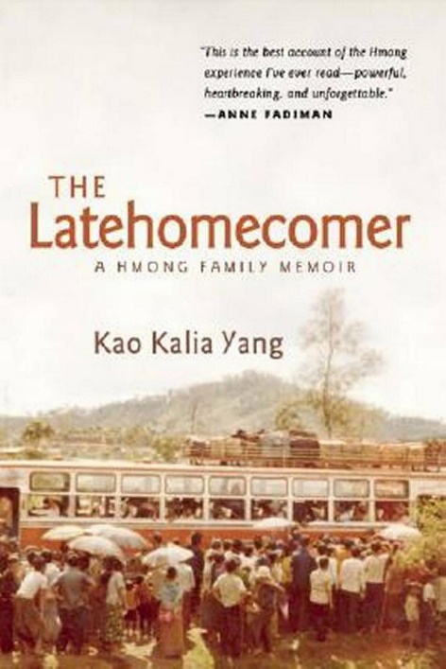
June 08, 2017 10:48 AM

Refugee memoir is Wichita’s 2017 Big Read selection

By Suzanne Perez Tobias
stobias@wichitaeagle.com
A memoir by a Hmong-American woman whose grandmother journeyed with her family from a prison in Laos to public housing in Minnesota is the selection for this year’s Wichita Big Read.
Wichita Public Library officials said “The Latehomecomer: A Hmong Family Memoir,” by Kao Kalia Yang, was chosen as the city’s 10th Big Read selection because its themes of immigration and family tradition are relevant to Wichita readers.
“It tells the story of a refugee who came to the United States, and we think that there are a lot of stories like that in Wichita,” said Julie Sherwood, program and outreach manager for the Wichita Public Library.
“We think there’s a lot to learn from the struggles that those people have faced, and hopefully it can offer some enlightenment.”
It tells the story of a refugee who came to the United States, and we think that there are a lot of stories like that in Wichita.
Julie Sherwood, program and outreach manager for the Wichita Public Library
The library received a $16,000 grant from the National Endowment for the Arts to help finance this year’s Big Read, a community-wide program that encourages diverse audiences to read the same book and participate in events designed around its theme. The event will run from Oct. 1 to Nov. 15.
Yang wrote the memoir as a “love letter” to her grandmother, whose spirit held her family together through a harrowing escape across the Mekong River and into a refugee camp in Thailand. They immigrated to St. Paul, Minn., when Yang was 6.
The Hmong (pronounced “mung”) are members of an ethnic group from the mountainous regions of China, Vietnam, Laos, Myanmar and Thailand. In the early 1970s, during the Communist takeover of Laos and the fall of Saigon, many Hmong migrated to the United States, settling primarily in California, Minnesota and Wisconsin.
It is the first nonfiction title selected for Wichita’s Big Read.
Sherwood said the author will visit Wichita on Oct. 12 as part of this year’s Big Read events.
Newman University has selected “The Latehomecomer” as its common read for incoming freshmen, she added. The author is expected to participate in programs at the university as well as at some Wichita public schools.
The library also has selected four companion books for young readers: “It’s a Tiger!” by David LaRochelle (preschool); “Never Trust a Tiger” by Lari Don (primary grades); “Dia’s Story Cloth” by Thanhha Lai (intermediate); and “Inside Out & Back Again” by Rodman Philbrick (advanced).
For information about the Big Read, including events scheduled in conjunction with the book, visit www.bigreadwichita.org.
“That event calendar is going to keep getting bigger and bigger as we get more programming and groups sign on to participate,” Sherwood said. “So we want people to keep checking back.”
Big Reads happen all over the country, with books ranging from “The Poetry of Emily Dickinson” to Alejandro Zambra’s “Ways of Going Home.” According to the NEA website, the program seeks to showcase “a diverse range of contemporary books that reflect many different voices and perspectives … to inspire conversation and discovery.”
Wichita participants will be invited to pick up a free copy of this year’s book at a Big Read kick-off at the Wichita Art Museum on Sept. 23. Throughout October, they’ll be encouraged to ask one another the Big Read’s big question: “What page are you on?”
Sherwood said it has been exciting to watch Wichita’s Big Read grow through the years and to witness how communal reading can bring the community together.
It’s really a value to society to have people who are readers.
Julie Sherwood, program and outreach manager for the Wichita Public Library
“When people are readers, they are more likely to be volunteers, they are more likely to vote, they are more likely to participate actively in their communities,” she said. “So it’s really a value to society to have people who are readers.”
Suzanne Perez Tobias: 316-268-6567, @suzannetobias
A decade of Big Reads
This year’s Big Read — “The Latehomecomer” by Kao Kalia Yang — marks the 10th selection for Wichita’s common-read program. Here’s a look back at previous selections:
2016: “Fahrenheit 451” by Ray Bradbury
2015: “Into the Beautiful North” by Luis Alberto Urrea
2014: “The Maltese Falcon” by Dashiell Hammett
2013: “True Grit” by Charles Portis
2012: “The Great Gatsby” by F. Scott Fitzgerald
2011: “The Things They Carried” by Tim O’Brien
2010: “Their Eyes Were Watching God” by Zora Neale Hurston
2009: “Great Tales and Poems of Edgar Allan Poe” by Edgar Allan Poe
2008: “My Antonia” by Willa Cather

