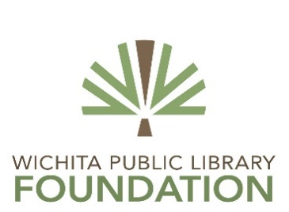

DATE: June 22, 2016 FOR IMMEDIATE RELEASE
CONTACT: Tom Borrego, Campaign Director, (316) 261-8545, tborrego@wichita.lib.ks.us

Wichita Public Library Foundation Receives
$250,000 Gift from the Capitol Federal® Foundation

The Wichita Public Library Foundation announced today a $250,000 gift from the Capitol Federal® Foundation as part of its “Margin of Excellence Campaign” to build Wichita’s new Advanced Learning Library.

Don Barry, Chairperson for the Wichita Public Library Foundation, is enthusiastic about the community support the campaign is receiving. “We are grateful that the Capitol Federal Foundation Board of Directors is making this significant investment in Wichita’s new Advanced Learning Library. This gift will enable the library to make a significant difference in our community.”

“Capitol Federal is proud to sponsor such a remarkable effort,” said Tammy Dishman, President of the Capitol Federal Foundation. “The new Advanced Learning Library will not only enhance literacy, but it will help educate, inform and enrich the entire Wichita community. CapFed® is honored it could be a part of this special project.”

The Capitol Federal Foundation was established in 1999 to serve as "A Community Cornerstone" within the communities in which Capitol Federal® operates. The Foundation is committed to improving the quality of life in these communities by investing in the citizens of today and tomorrow. The main areas of focus for accomplishing this mission include:
- Education
- Community development and housing
- The United Way
- Other charitable purposes

A Commitment to the Community is a tradition Capitol Federal began in 1893. The Capitol Federal Foundation honors this tradition by strengthening the “Community Cornerstone” for future generations.

“This gift is a wonderful demonstration of Capitol Federal’s commitment to the communities they serve. The vision of this project depends on those who cherish the advancement of education, opportunity and preservation of our collective community history,” said Honorary Library Campaign Chairperson, Mary Lynn Oliver.

The Advanced Learning Library Capital Campaign serves to augment the City’s $30 million investment in what is being called “a community keystone project.” The campaign has secured more than $6.0 million toward its $8 million goal.

